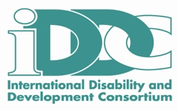
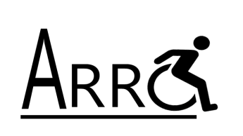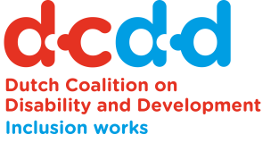

Call for participation at the 8th
Disability Networking Zone
“Disability Inclusive AIDS Response”

In the Global Village at the 22nd International AIDS Conference

23rd – 27th July 2018
Amsterdam

An initiative of the Dutch Coalition on Disability and Development (DCDD), the Afrique Rehabilitation and Research Consultants NPC (ARRC) and International Disability and Development Consortium (IDDC) and its partners

Objective
Despite advances in knowledge on the intersection between disability and HIV, many people with disability still lack access to information, counselling and testing and treatment and care. In addition, through increased access to Antiretroviral Therapy, AIDS-related deaths have declined and people’s life expectancy has improved. However, living long with HIV comes with new health-related challenges and potentially episodic, temporary and permanent disabilities.

Currently, disability and rehabilitative services are scarce and thus not fully-equipped to meet these increased needs, or to effectively link up with existing HIV-services to make these more disability inclusive. The 8th edition of the Disability Networking Zone (DNZ) will be held in the Global Village of the 22nd International AIDS Conference in Amsterdam and aims to:
- Increase awareness and knowledge on the intersection of disability and HIV;
- Disseminate and present cutting edge research evidence;
- Disseminate good practice and innovations through diverse formats;
- Enhance engagement and dialogue with researchers, donors, advocates and people with disability;
- Enhance strategic networking among disability-orientated organisations, Disabled People’s Organisations, mainstream AIDS-related NGOs, government, stakeholders, Researchers, Clinicians and activists; and
- Actively involve people with disability and people living with HIV who experience disablement on an episodic, temporary or permanent basis, in particular youth with disability.

Who can apply?
We are calling for participation from grassroots and national DPOs, NGOs, Faith-Based Organizations, networks, Researchers, institutions and other organisations and leaders in the field of disability and HIV from around the world to join us in advancing the above Objectives.

In our networking zone people with disability, people living with HIV, Researchers, donors and conference attendees can come together to share experiences, learn from each other and raise awareness of the intersection between disability and HIV.

Activities
We invite you to apply to host an activity related to disability and HIV such as:
- Exhibition posters on examples of Good Practice
- Presentations and discussions on Good Practice or innovative advocacy ideas
- Presentations of new research findings and evidence
- Interactive skills-building sessions of Good Practice
- Film screenings
- Testimonies of people with disability who also are infected or affected by HIV and people living with HIV
- Presentation of policy papers and information material
- Round table discussions with key stakeholders in the field of HIV and/or disability

How to apply?
Complete and submit the attached application form to Vernon Openshaw (vernon.openshaw@gmail.com) by 20th May 2018. Your application form should include contact details and not exceed 2 pages. You will be notified if your session has been accepted by 30th May 2018.

Unfortunately, we are not able to provide financial support for presenters or participants. Organisers must find their own funding for travel to Amsterdam, the Netherlands and all costs associated with participation in the AIDS 2018 Conference.

For more information on the conference and disability and HIV visit: http://aids2018conference.org

Application for Disability Networking Zone in the Global Village at the 22nd International AIDS Conference in Amsterdam 2018

Note: Total length of application should not exceed 2 pages and be sent to Vernon Openshaw (vernon.openshaw@gmail.com).

Part I: General Information

Name of your Organisation: _____________________________________________
Contact person: ______________________________________________________
Email address: _______________________________________________________
Contact No (including country dialling code): _______________________________
Fax No (including country dialling code): ___________________________________
Address: ____________________________________________________________
City: _______________________________ Country:________________________
Website: ____________________________________________________________
Brief Organisational Description including activity types (half-page maximum)

Part II: Activity Information

Type of Activity you are proposing (please mark)

Exhibition
Presentation
Dialogue session
Skills-building/training session
Film
Other (specify below)

Title and 1-2 sentence summary description of your Activity

Description of your activity (half page max)

Objectives of your activity (quarter page max)

Length of session (2 hours maximum)

Preferred day/time? (please give more than one option)

Primary language of your activity

Please indicate in which sign language your session will be accessible?

How will you publicise the activity?

